**SAP Analytics Cloud | SAP Lumira**

**Sales Data Analysis**

**Aayush Shirish Desai**

**Date: 12/7/2023**

In July 2023, I undertook this project to conduct comprehensive data analysis on bike sales using SAP Cloud Analytics, aiming to derive insights into sales performance, customer behavior, and market trends to inform strategic decision-making and optimize business processes.

**Sales Data Analysis of Bikes and bike products using SAP Cloud Analytics and SAP Lumira.**

Analyzed a comprehensive sales dataset containing 29,189 entries and 18 columns, detailing transactions for various products, customers, and regions from 2007 to 2011.

**Here are my key takeaways**:

1. Calculated Net Sales Per Calendar Year and Product Category, with the year 2007 recording the highest net sales, particularly for the product categories ORB, ROB, and TOU, i.e., Types of Off-Road Bikes, Road Bikes, and Touring Bikes, respectively.

2. Analyzed customer revenue per calendar year in 2007 and found that Bavaria Bikes generated the highest revenue.

3. Assessed Overall Revenue Per Calendar Year Customer and discovered that 2007 had the highest revenue among the bottom five customers, followed by 2008.

4. Evaluated Revenue Per Calendar Year Sales Organization and identified that the Germany North region recorded the highest revenue in 2011.

5. Examined Revenue Per Material Description and Sales Organization for 2011 and found that the Professional Road Bike was the top revenue-generating material in the Germany North region.

6. Tracked the Number of Bikes Sold to Customer Alster Cycling in 2011, noting 343 number of bikes sold.

7. Investigated Seasonality in Materials and determined that materials like Air Pump, Elbow Pads, First Aid Kit, Knee Pads, Off Road Helmet, Repair Kit, Road Helmet, T-shirt, Water Bottle, and Water Bottle Cage did not exhibit seasonality.

8. Measured the Average Days Between Quotation and Payment Per Sales Area and observed number varied between 39.21 and 40.87 across 8 different sales areas.

**Tools Used:**

* SAP Cloud Analytics and for data processing and visualization.
* SAP Lumira for visualization.
* Excel for dataset management and initial data exploration.

**Skills Demonstrated:**

* Proficient in data analysis and visualization using SAP Cloud Analytics and SAP Lumira.
* Ability to interpret complex datasets and extract actionable insights.

**Individual Project Part 1**

1. **Net Sales Per Calendar Year, Product Category.**

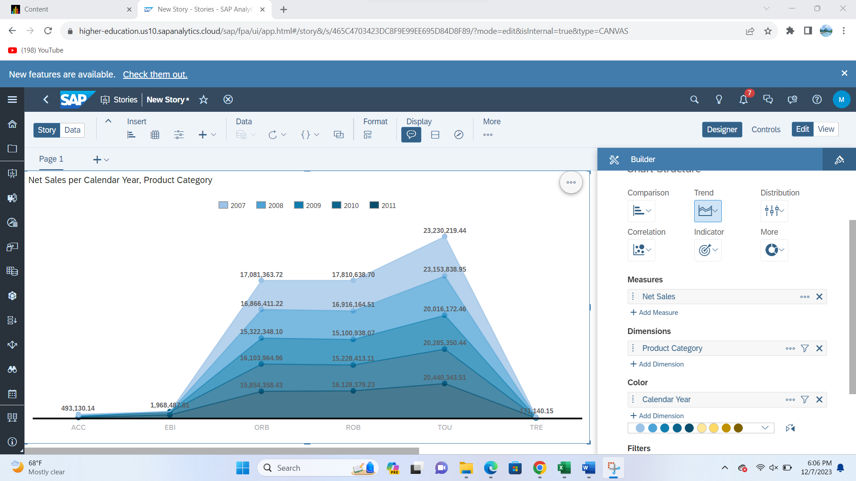

The above data tells us that 2007 had the overall highest net sales and for the product categories ORD, ROB and TOU

1. **Revenue per Calendar Year, Customer for year 2007**

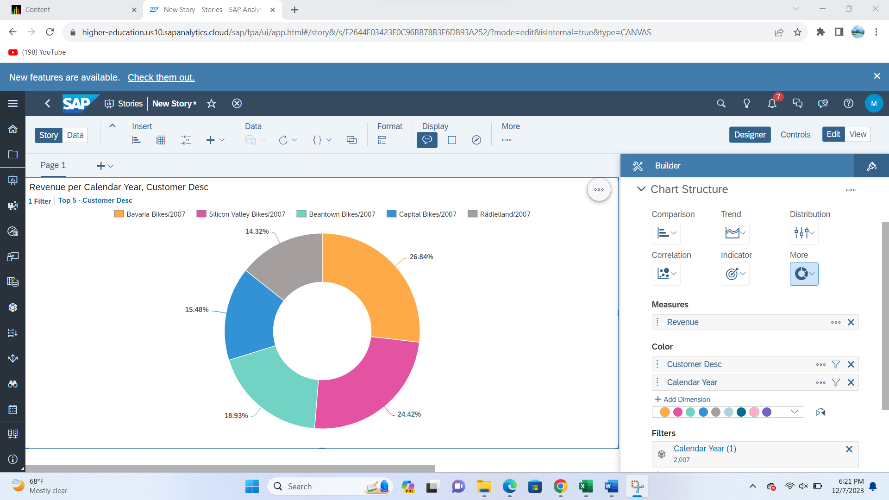

As from the 1st screenshot we discovered that 2007 had the overall highest net sales, therefore in screenshot of the Donut graph shows the top 5 customers, we discover that in 2007 the highest revenue was generated from Customer Bavaria Bikes.

1. **Revenue per Calendar Year, Customer**

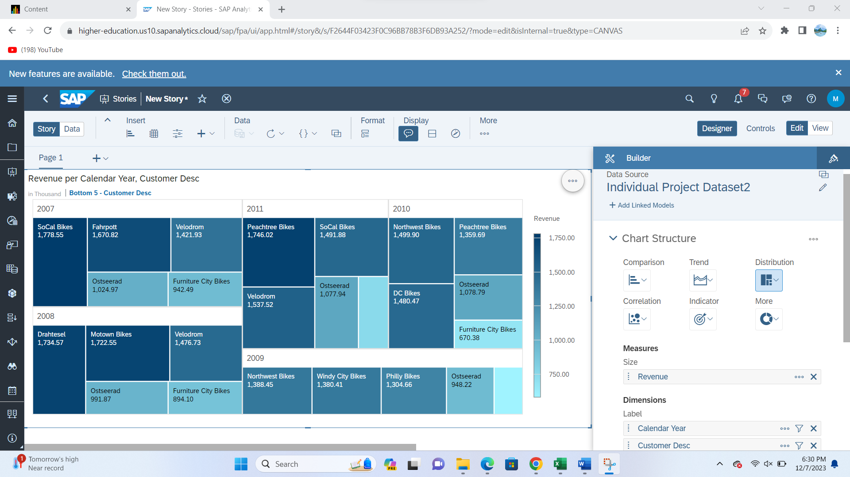

Th above Tree map tells us about the revenue overall all the years for bottom 5 customers. From which we get to know 2007 had the highest revenue and 2008 had the second highest revenue

1. **Revenue per Calendar Year, Sales Org**

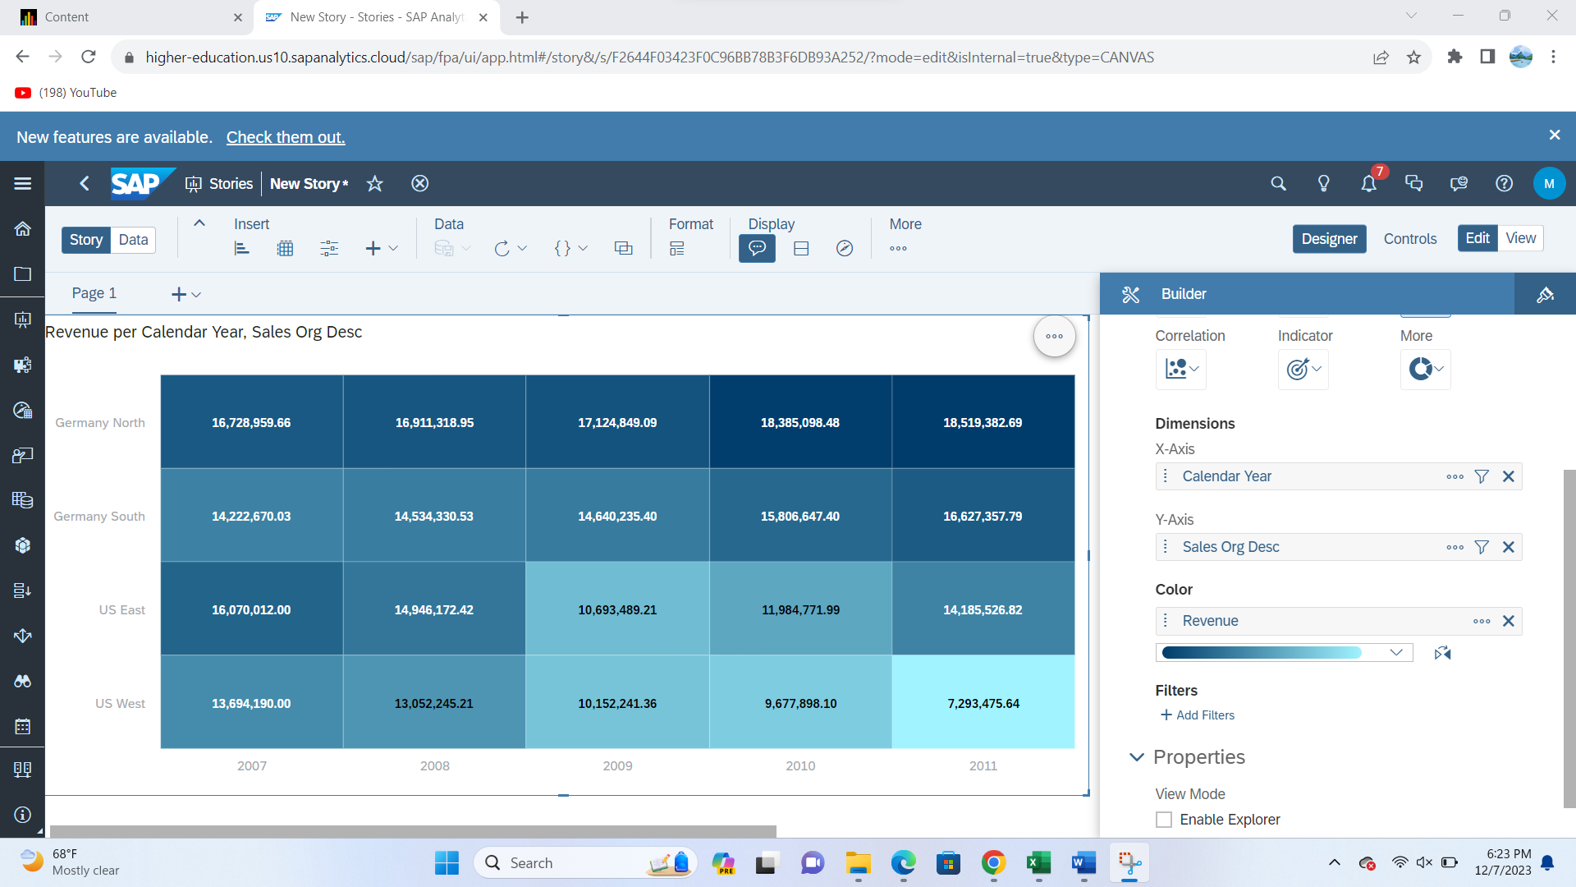

The above Screenshot of a heatmap tells us that 2011 had the revenue for the Germany North Region.

1. **Revenue per Callender Year, Material Desc and Sales Organization for year 2011**

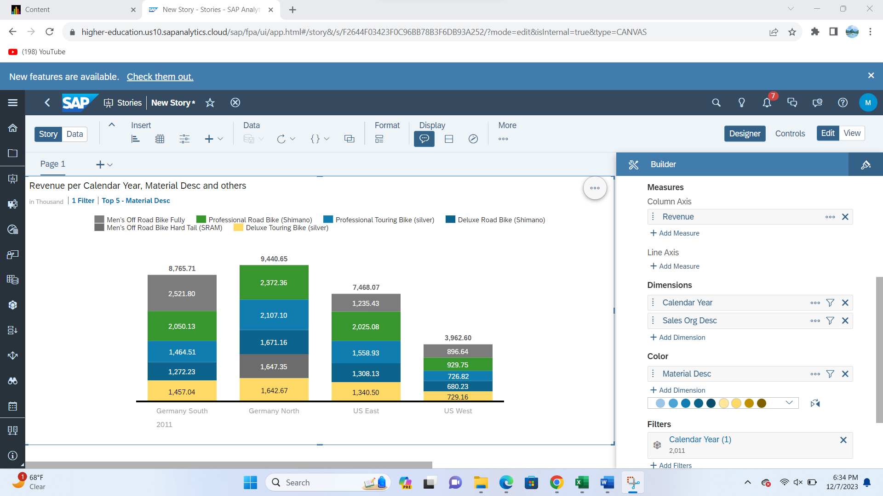

From screenshot 5 we know 2011 had the highest revenue in Germany North. This above screenshot 5 tells us which material made highest revenue in the sales organization regions. It tells us Professional Road Bike had the highest revenue in 2011 in Germany north region.

**Individual Project Part 2**

**Aayush Shirish Desai**

**Date: 12/7/2023**

**Report 1**

Number of bikes sold to customer Alster Cycling in year 2011.

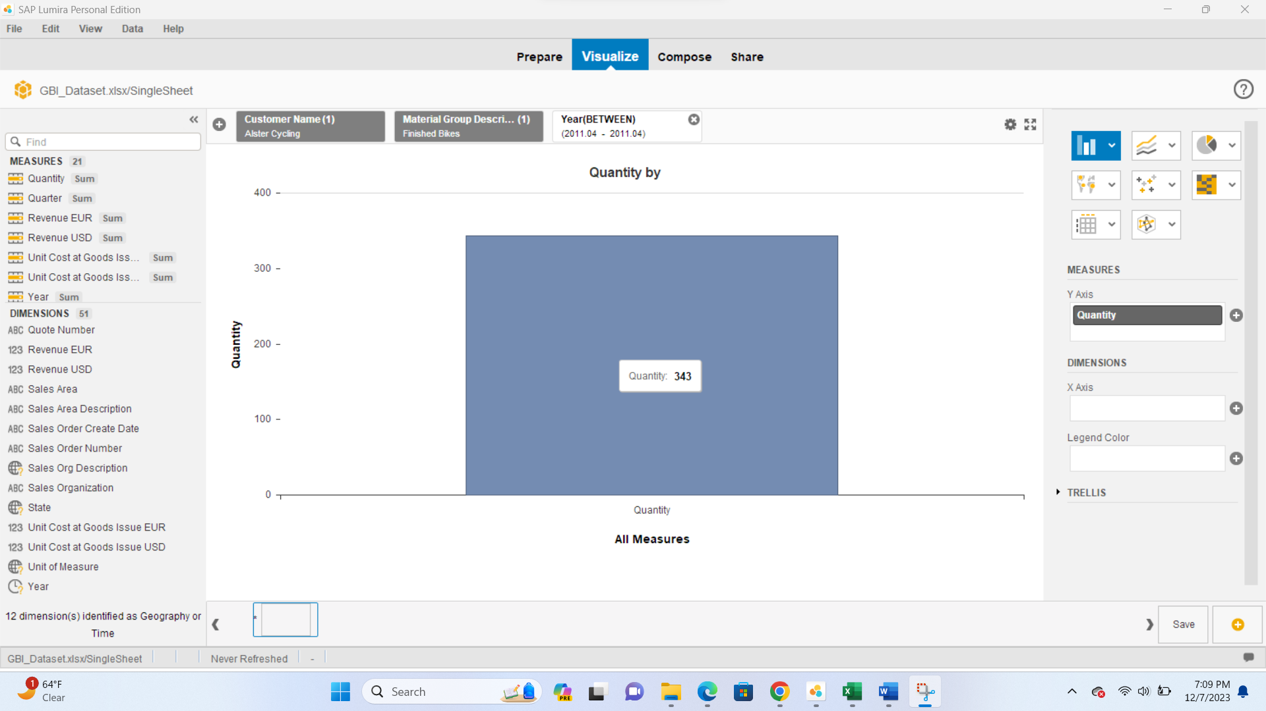

**Report 2**

Is there any Material that doesn’t display seasonality?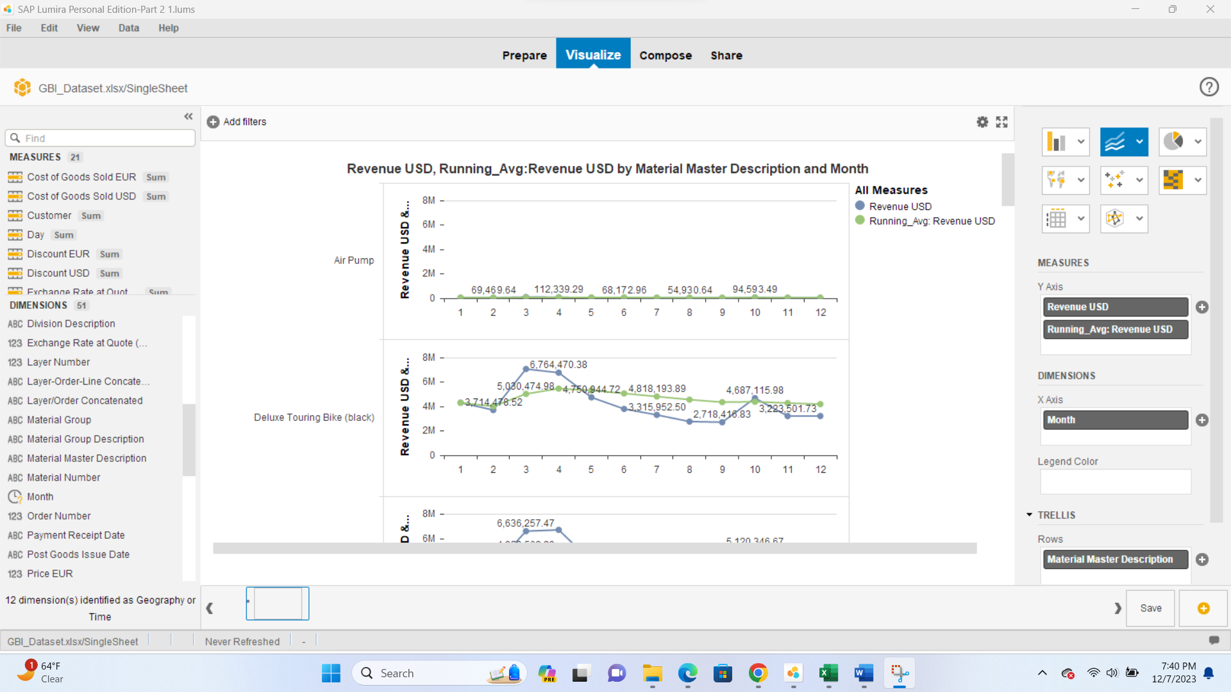

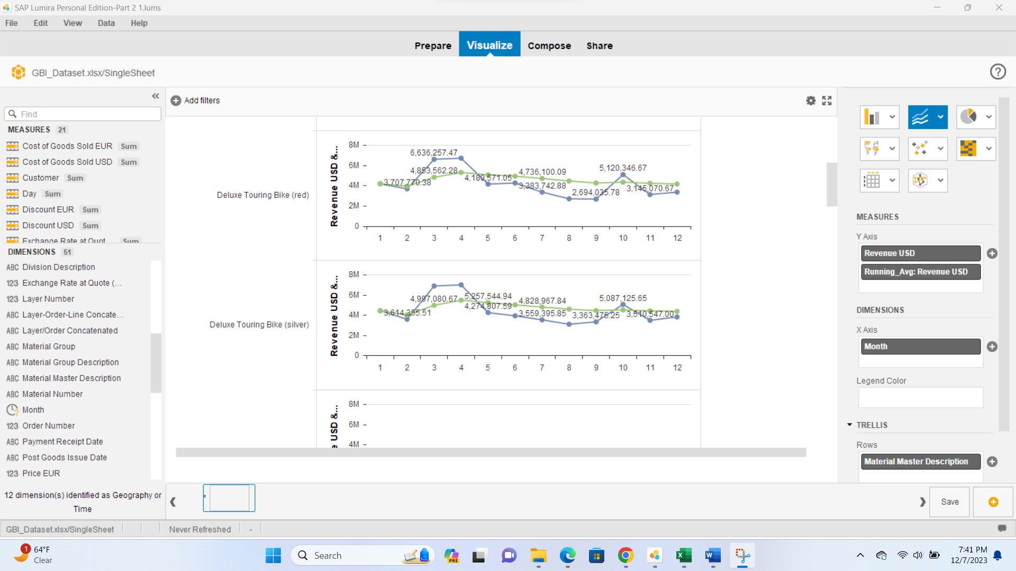

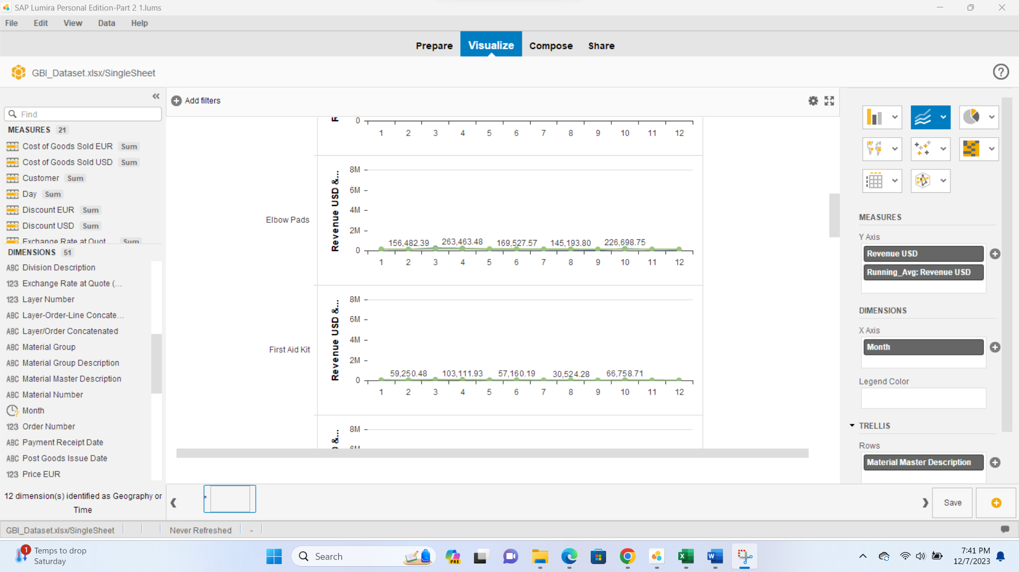

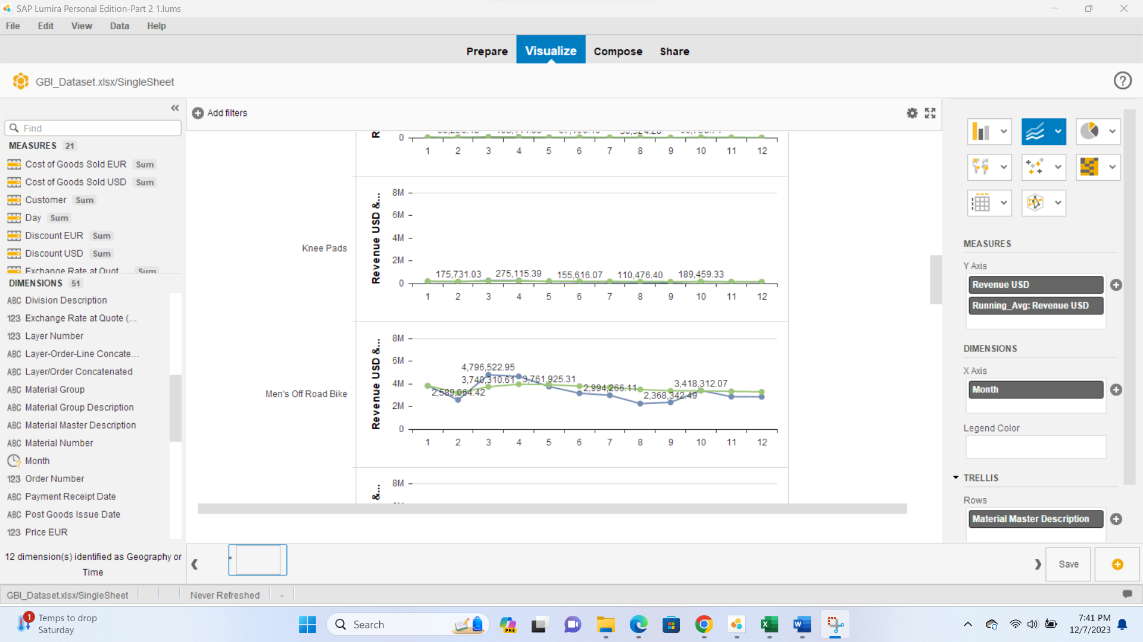

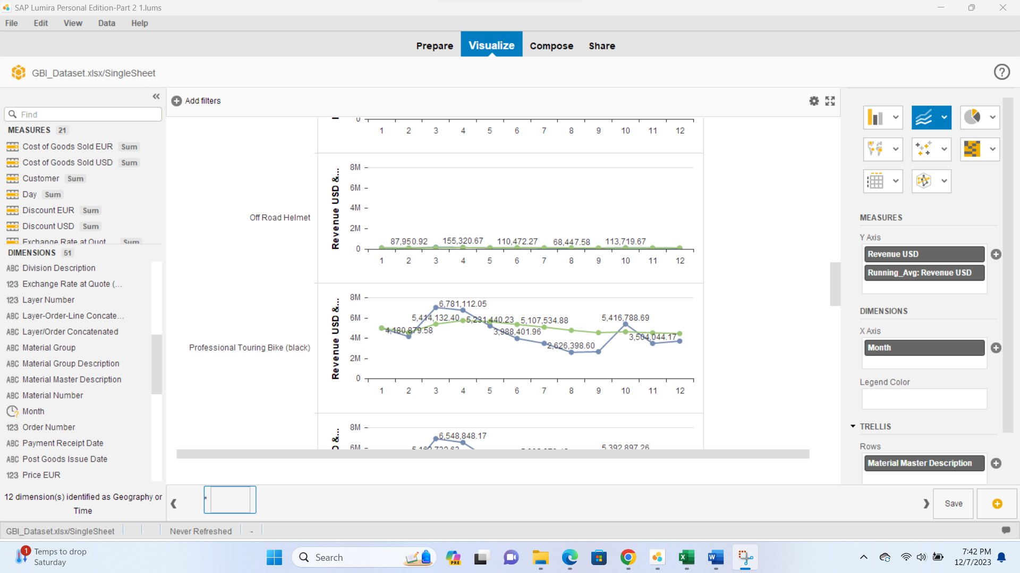

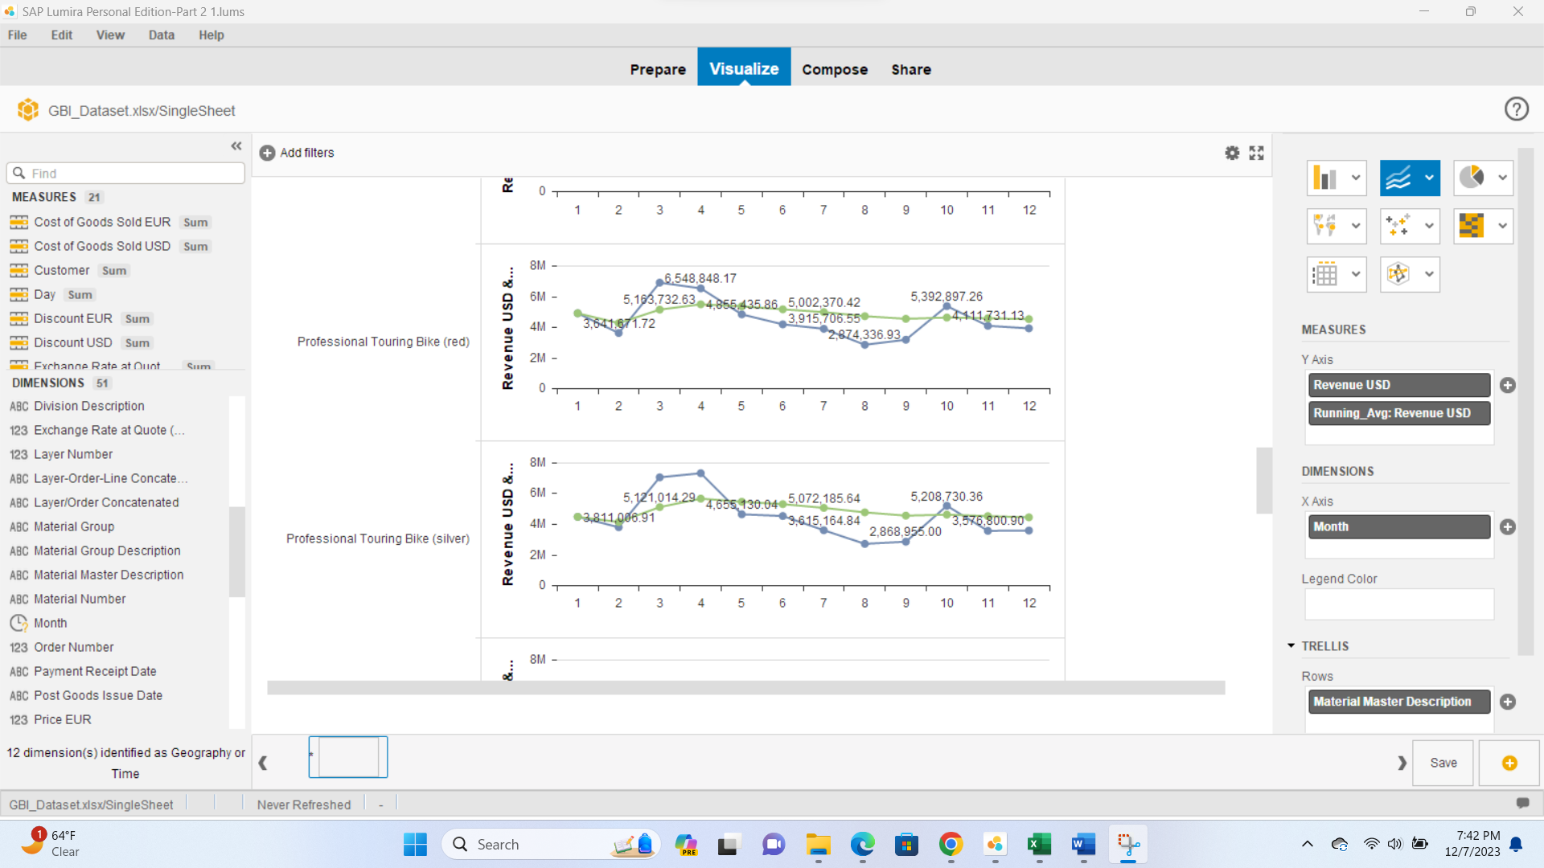

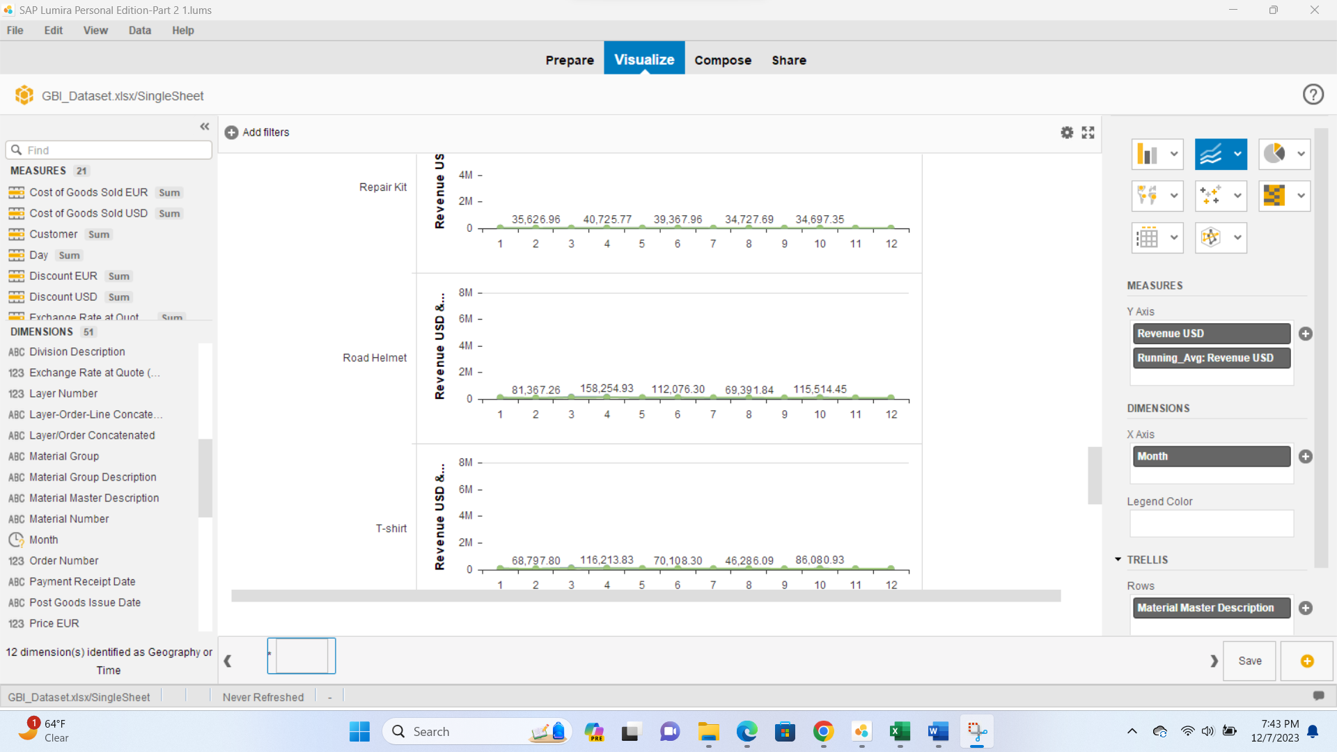

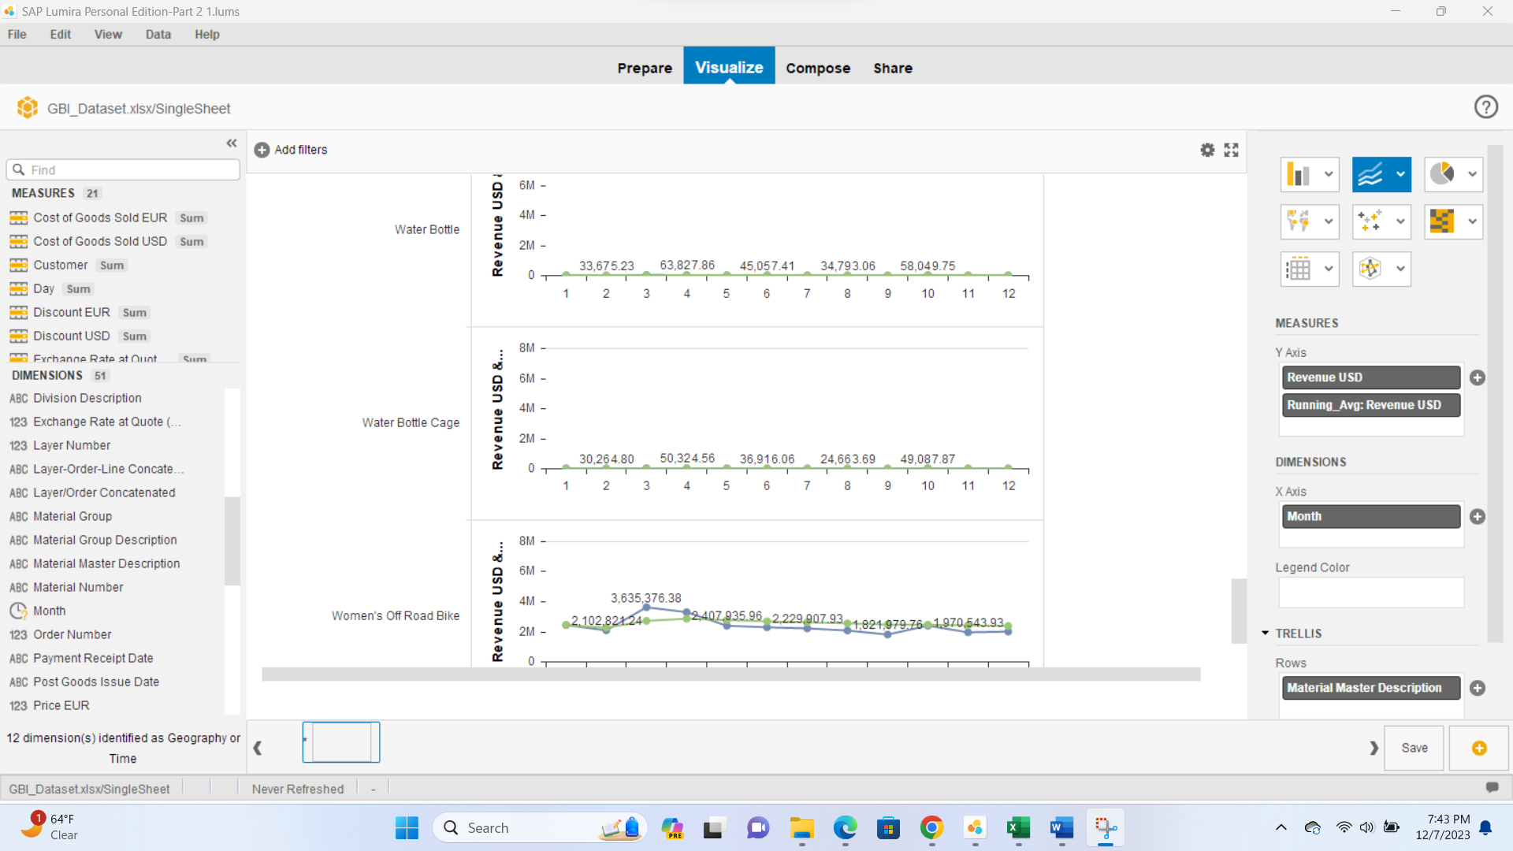

Air Pump, Elbow Pads, First Aid Kit, Knee Pads, Off Road Helmet, Repair Kit, Road Helmet, T-shirt, Water Bottle, and Water Bottle Cage don’t display seasonality.

**Report 3**

Average number of days between quotation & payment per sales area (exclude year 2013)

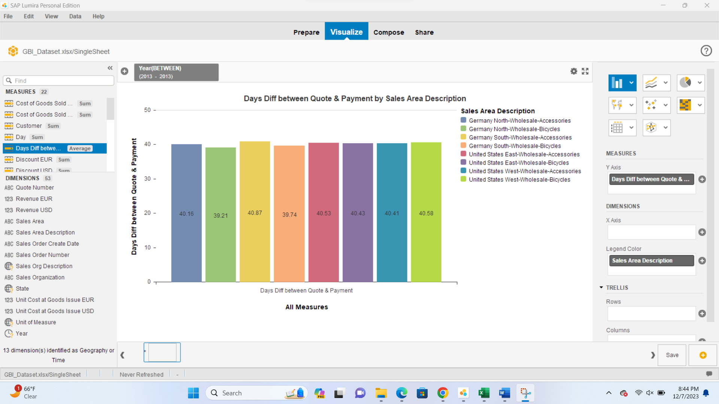

Average number of days between quotation & payment per sales area are as follows show in the above screenshot.